PRACTICAL: 07
Aim: Implementation of making a change problem using dynamic programming.
Algorithm:
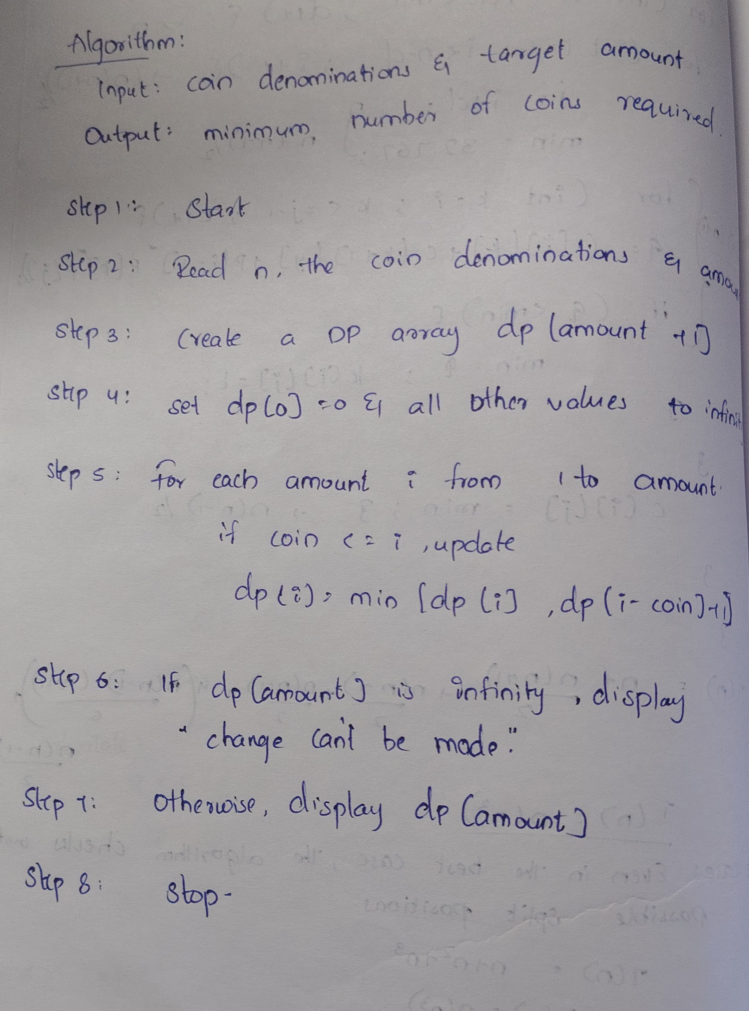

Program / Code:
#include <iostream>
using namespace std;

class ChangeMaking
{
private:
int coins[10];
int n;
int w;
int A[10][100];

public:

void getInput()
{
cout << "Enter number of coin types: ";
cin >> n;

cout << "Enter coin values: ";
for (int i = 1; i <= n; i++)
{
cin >> coins[i];
}

cout << "Enter amount: ";
cin >> w;
}

void solve()
{
// There is 1 way to make amount 0:
// select no coins
for (int i = 0; i <= n; i++)
{
A[i][0] = 1;
}

// With 0 coin types, no positive amount can be made
for (int j = 1; j <= w; j++)
{
A[0][j] = 0;
}

// Fill the DP table
for (int i = 1; i <= n; i++)
{
for (int j = 1; j <= w; j++)
{
if (coins[i] > j)
{
A[i][j] = A[i - 1][j];
}
else
{
A[i][j] = A[i - 1][j]
+ A[i][j - coins[i]];
}
}
}
}

void printTable()
{
cout << "\nDP Table:\n";

cout << "Coin\t";

for (int j = 0; j <= w; j++)
{
cout << j << "\t";
}

cout << endl;

for (int i = 0; i <= n; i++)
{
if (i == 0)
cout << "0\t";
else
cout << coins[i] << "\t";

for (int j = 0; j <= w; j++)
{
cout << A[i][j] << "\t";
}

cout << endl;
}
}

void showResult()
{
cout << "\nTotal Number of Ways = "
<< A[n][w] << endl;
}
};

int main()
{
ChangeMaking c;

c.getInput();
c.solve();
c.printTable();
c.showResult();

return 0;
}

Output:
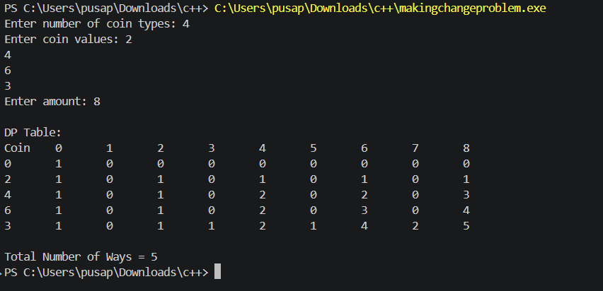

Time Complexity:
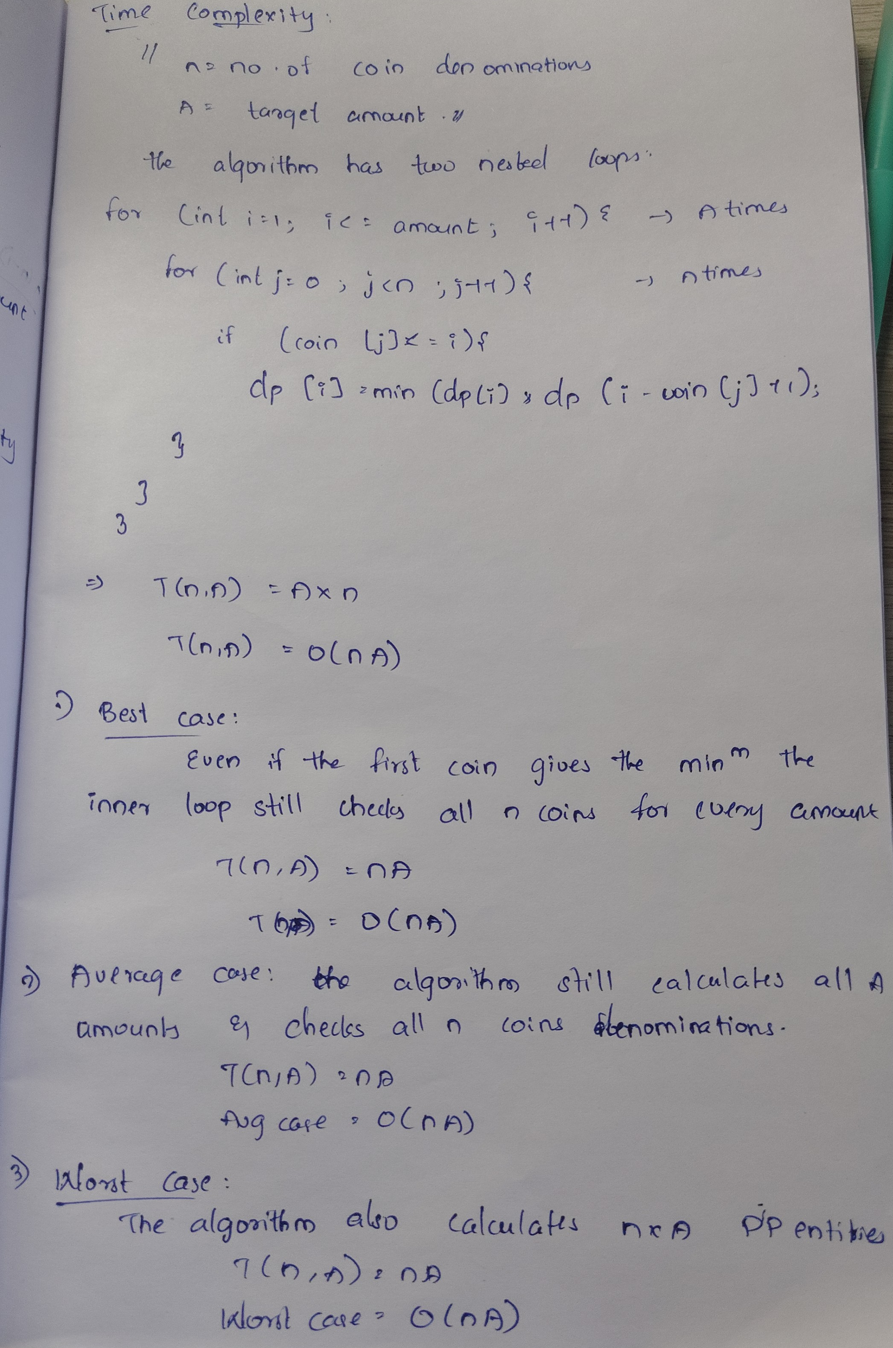

Conclusion:
The Dynamic Programming method efficiently calculates the total number of ways to make a given amount using the available coins. It avoids repeated calculations by storing previously computed results.

